• Lab Title: Lab 3: Command Injection

• Assignment Title: Lab 3: Command Injection
• Student Name: Bashir Adam
• Student ID: 2025/FWSD/11509
• Course Name: BVWS103– OWASP-Top-10-Vulnerabilities-Exploitationentials
• Instructor Name: Aminu Idris
• Date of Submission: 24 JAN, 2026
• Version: Version 2.3.0

LAB OVERVIEW/OBJECTIVE

Objective:
In this lab, you will:
- Understand what command injection vulnerabilities are.
- Learn how attackers can exploit command injections.
- Apply basic mitigation techniques to prevent command injection vulnerabilities.

Task 1: Exploit Command Injection Vulnerability
I first set up thevVulnerable web application by creating a folder named Lab 4 and inside the folder i created two file which are index.html and command.php

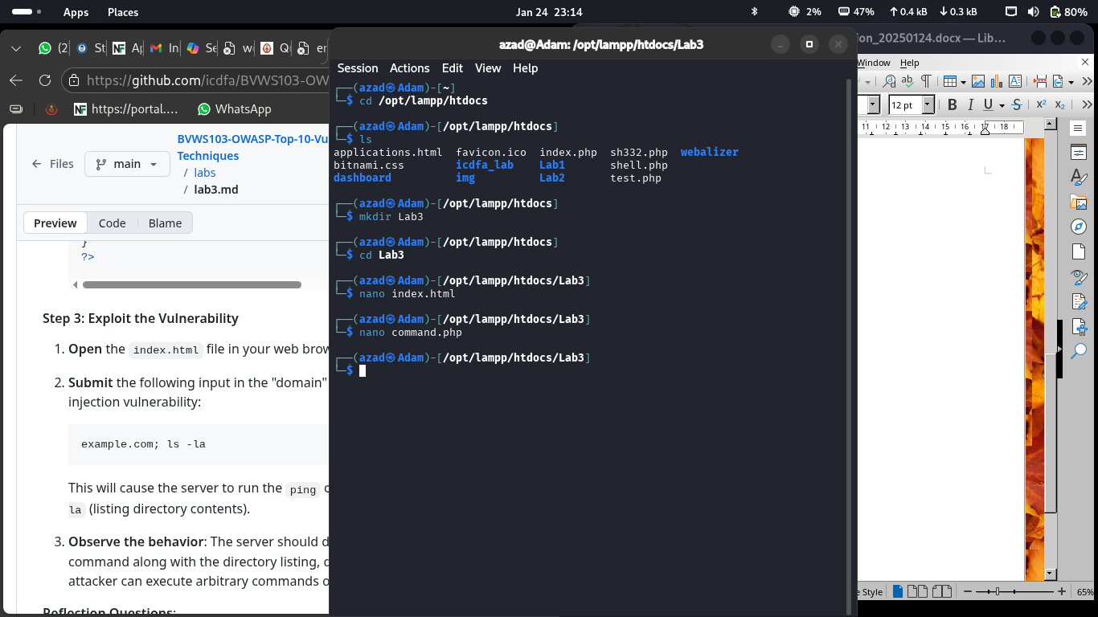

I implement the vulnerable code for the index.html

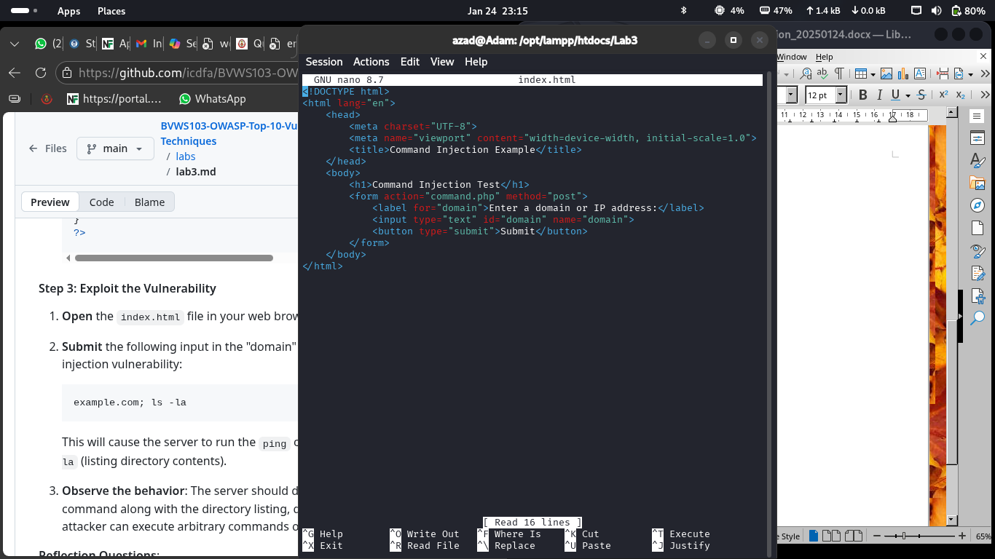

And I also implement the one for command.php

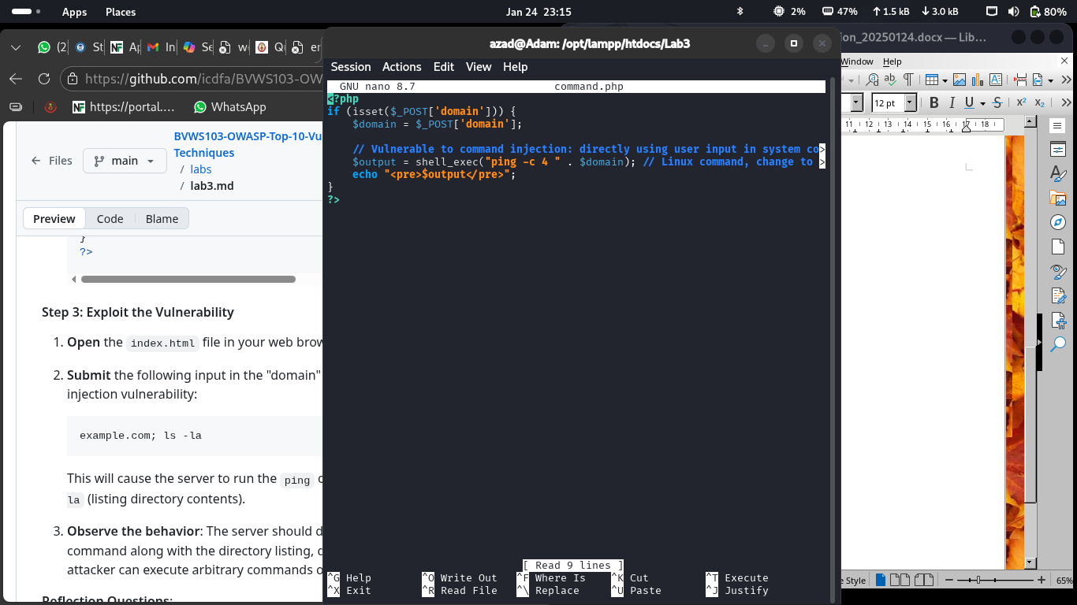

and I also start my Xampp server using the command “sudo /opt/lampp/lampp start”

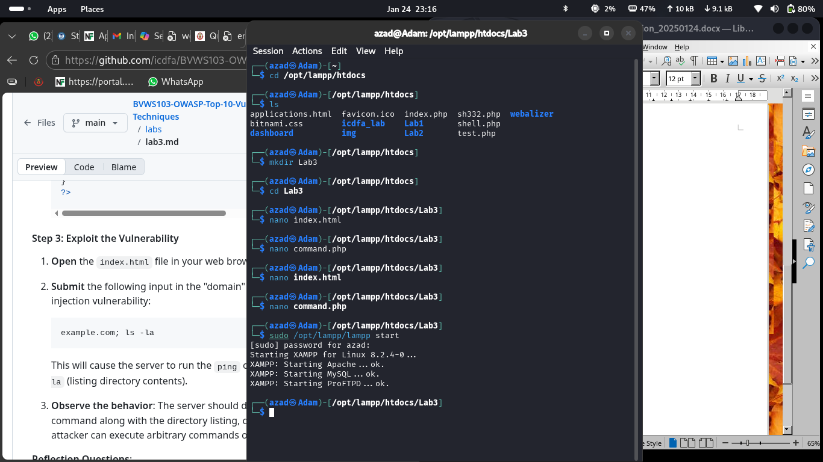

this is what is look like in my web browser (The vulnerable web page)

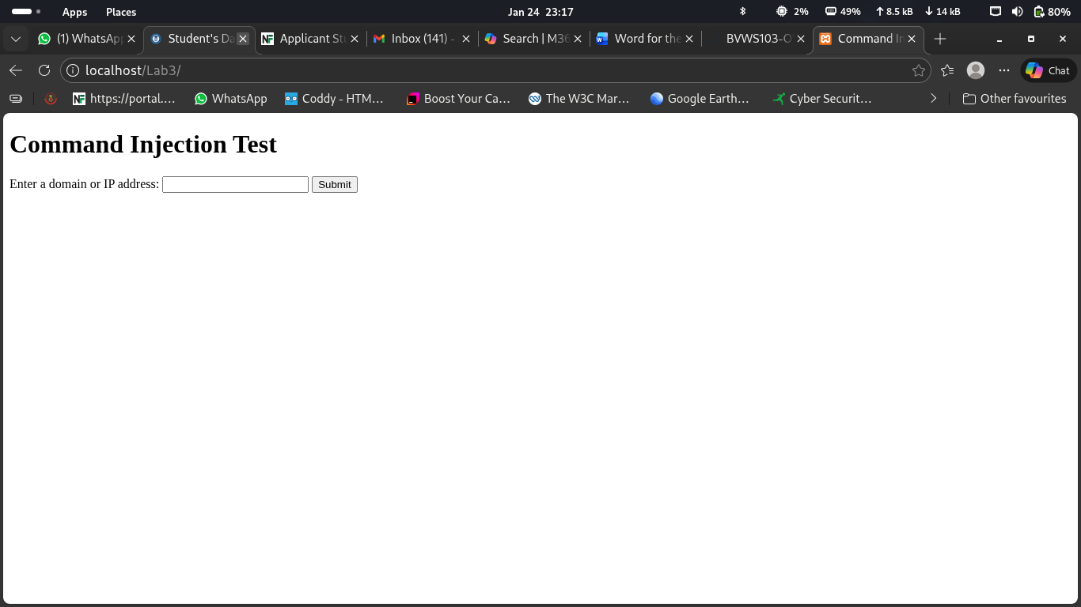

I input the domain ”example.com; ls -la” field to exploit the command injection vulnerability

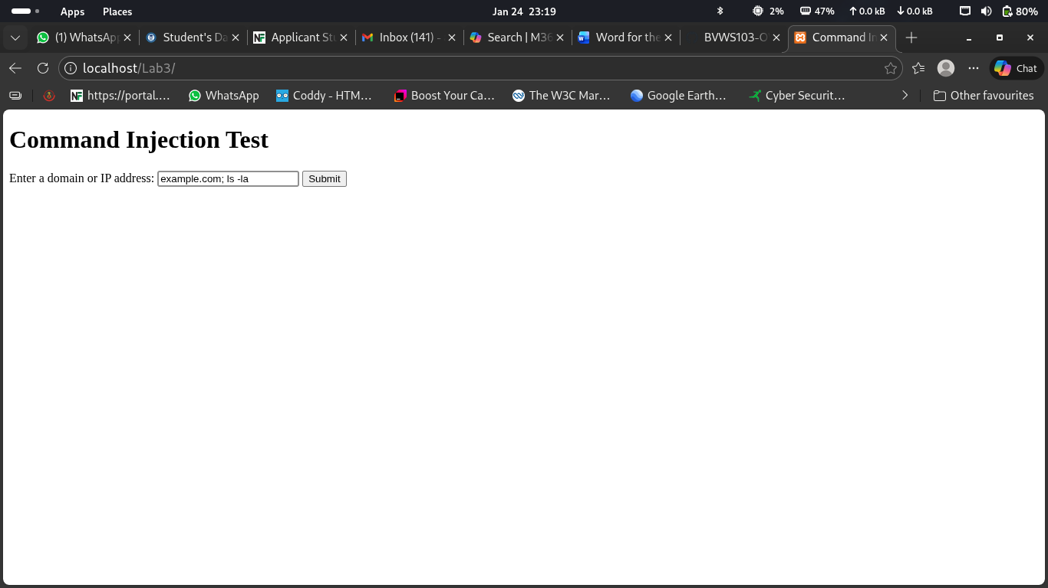

And here is the result which the server runs the ping command followed by ls -la which list the directory contents

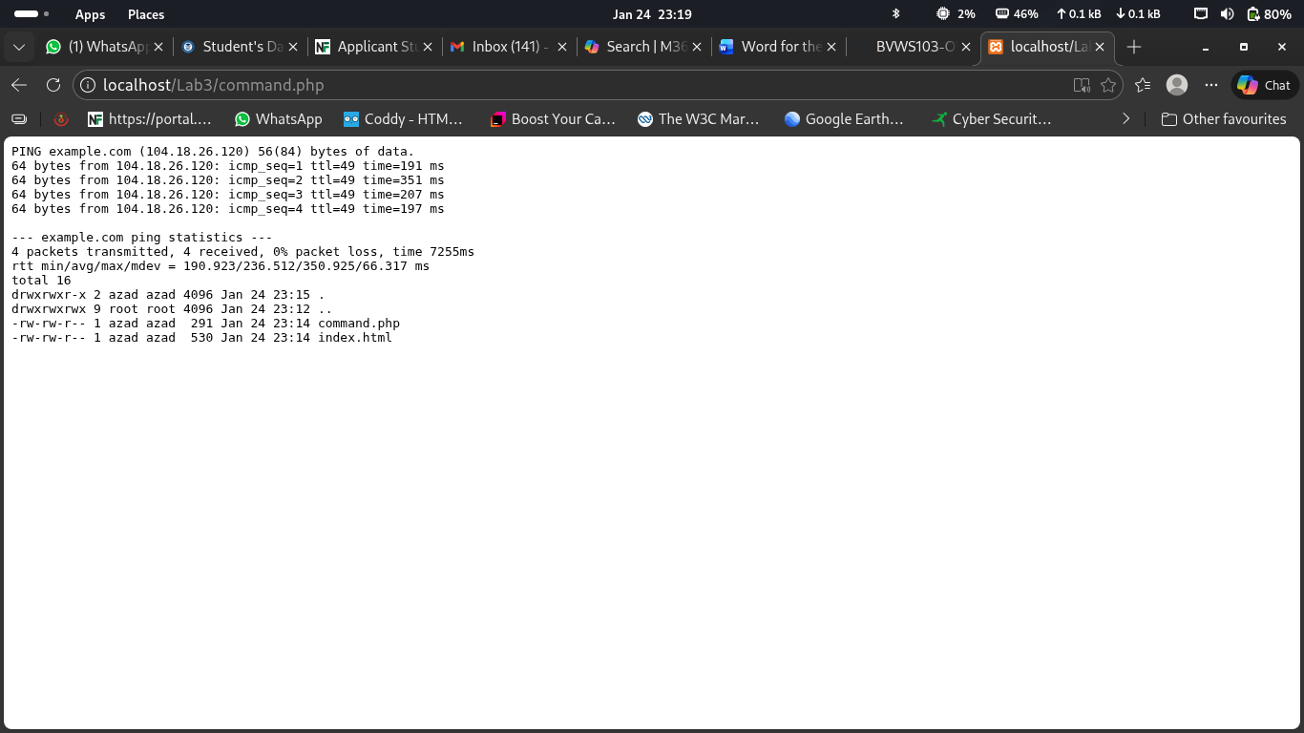

1. How does the ; symbol allow an attacker to chain commands together?
The semicolon (;) is a command separator. It tells the system to execute multiple commands one after another on the same line.

2. What risks are involved when web applications execute system commands based on user input?
Allowing user input to control system commands is extremely dangerous and can lead to serious security problems, such as:
- Unauthorized access to server files
- System compromise
- Data loss or corruption
- Website takeover or defacement
- Use of the server for illegal activities
- Loss of trust and legal consequences

Task 2: Mitigate Command Injection Vulnerability

To mitigate the command injection vulnerability, I modify the command.php file.
I use the function escapeshellcmd() to prevent command injection by escaping any special characters that could be interpreted as part of a command.

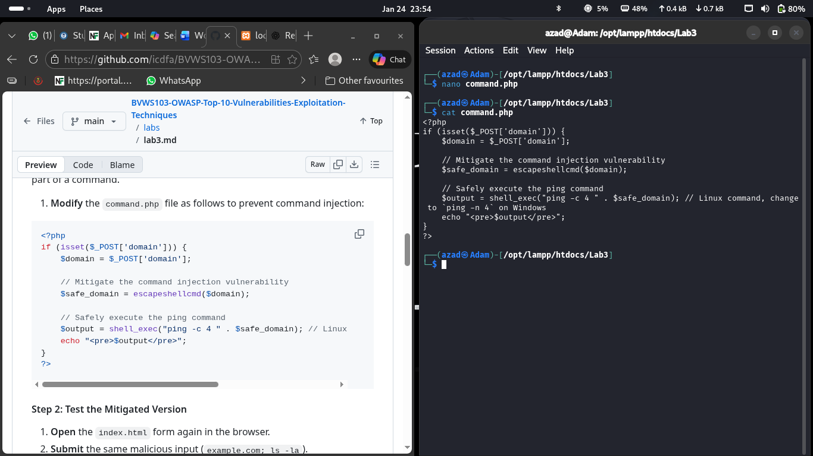

Modified command.php code

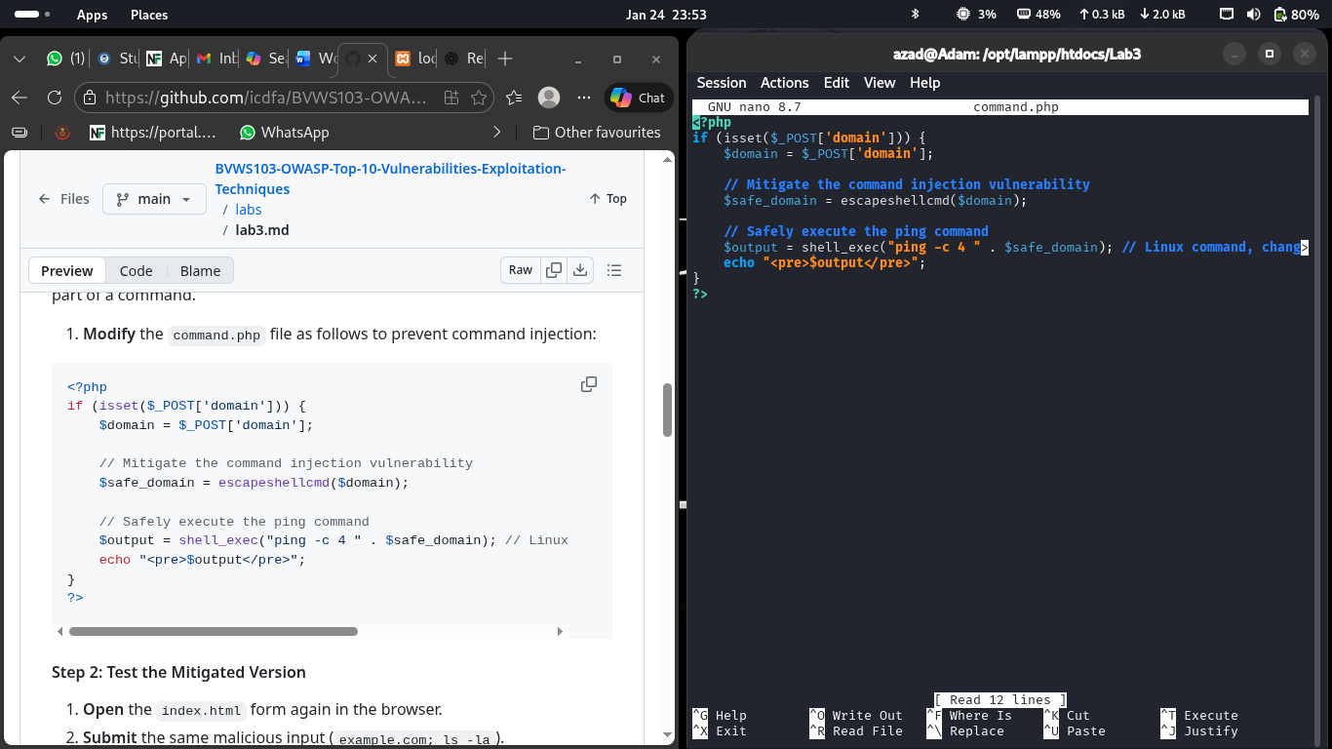

I Submit the same malicious input again to see what will happen
example.com; ls -la
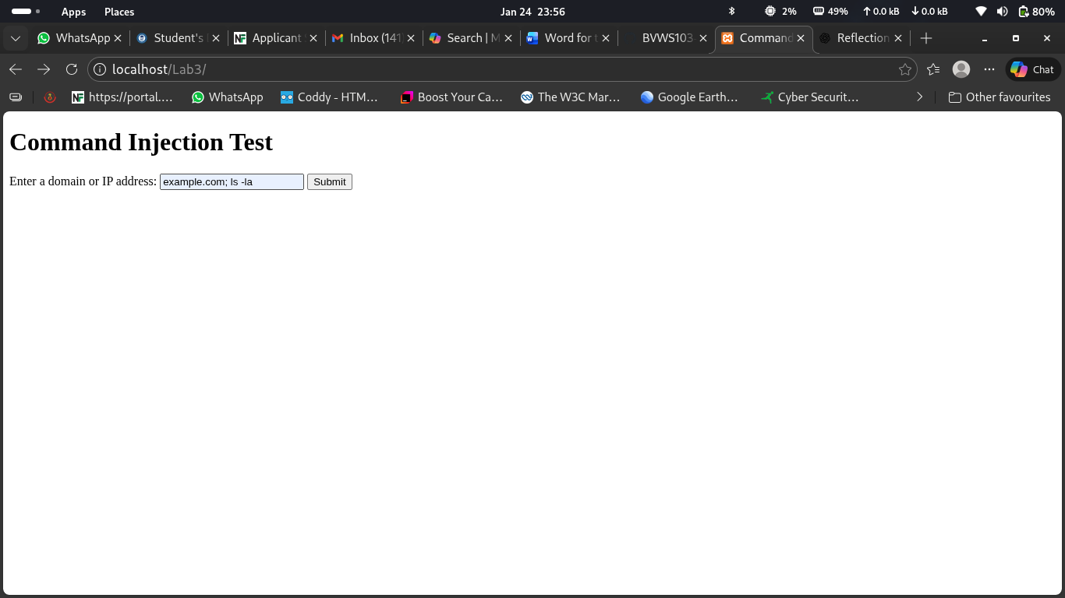

The results demonstrate that the vulnerability has been mitigated. No sign of vulnerability rather it does not execute any command

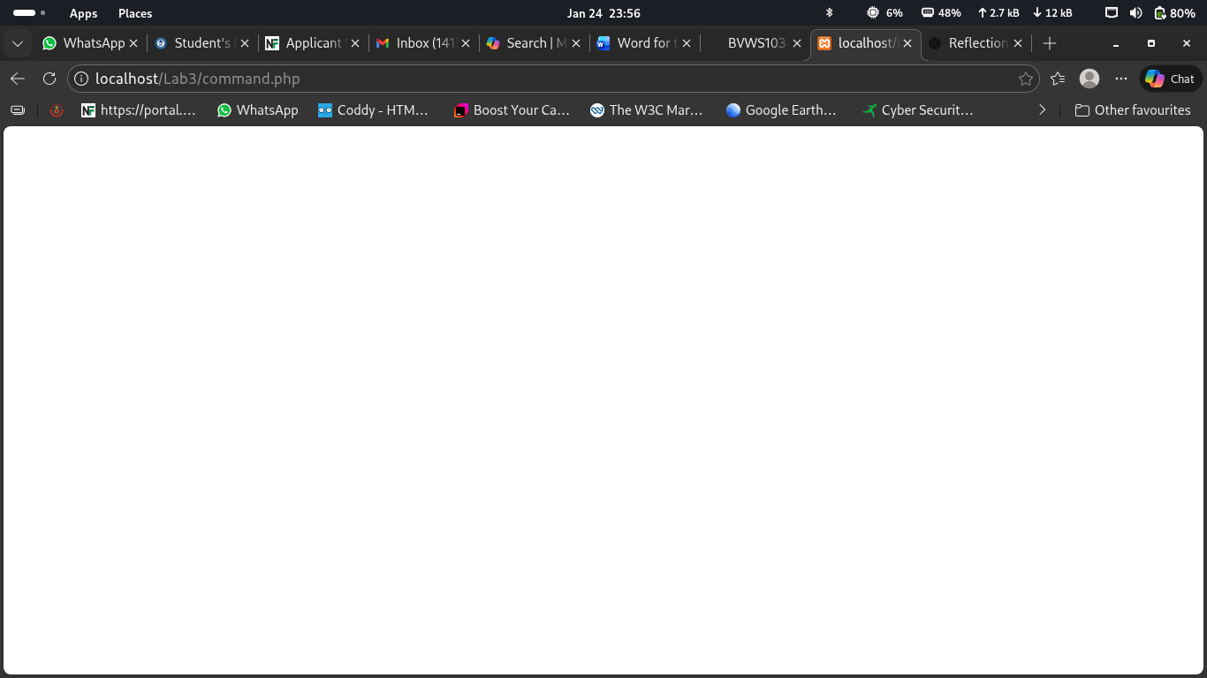

1. How does the escapeshellcmd() function prevent command injection?
The escapeshellcmd() function prevents command injection by escaping or neutralizing special characters that have meaning in system commands, such as: ; & | ` $ > < !

2. Why is it important to sanitize user input before using it in system commands?
Sanitizing user input is important because user input is untrusted and may contain malicious code. Without sanitization, attackers can manipulate system commands to:
- Execute unauthorized commands.
- Access or delete sensitive files.
- Take control of the server.
- Disrupt services and data integrity.

3. Can you think of other ways to secure this functionality?
Yes. Other ways to secure this functionality include:
- Avoid using system commands entirely and use built-in programming functions instead.
- Whitelist allowed inputs, such as allowing only valid domain names or IP addresses.
- Use parameterized or escaped shell arguments (e.g., escapeshellarg()).
- Run the application with limited system privileges to minimize damage if compromised.
- Implement input length limits and pattern validation using regular expressions.
- Log and monitor suspicious input attempts for security auditing.
Using multiple layers of security makes applications much harder to attack.

